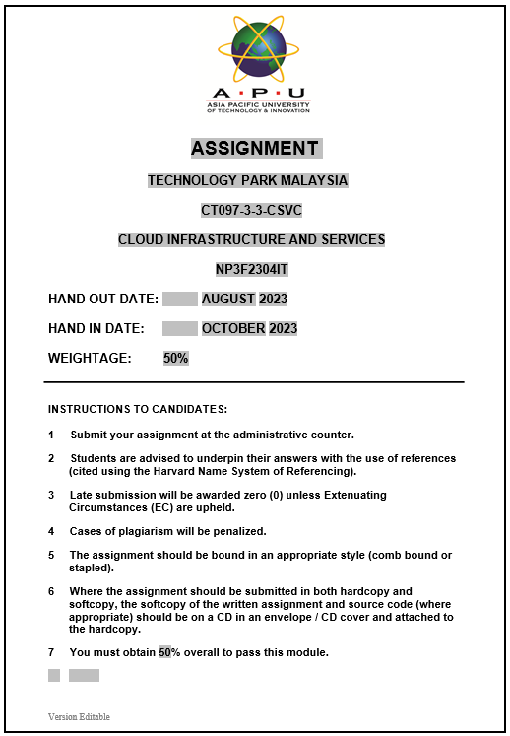

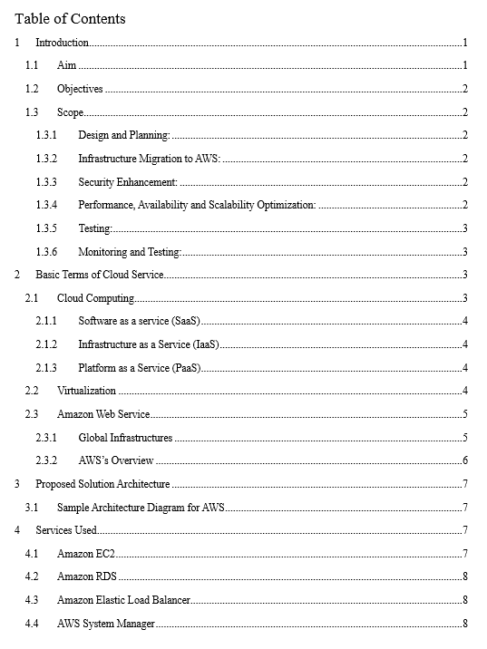

# Introduction

In this evolving landscape of IT enterprises and organizations, one of the emerging technologies has been cloud technology, which is a powerful force, offering various benefits such as on-demand self-service, expensive network access, rapid scalability, resource pooling and other measurable service outcomes. It’s within these services that current IT organization’s journey unfolds. Currently in this assignment our focus is on the Example Social Research Organization, a fictional non-profit which plays a pivotal role in the realm of social science research, offering valuable gateway to ensure a source of global development data, encompassing critical metrics like life expectancy trends over the past decade. This data is readily accessible to researchers through the organization’s dedicated website.

At the helm of this initiative, there is Shirley Rodriguez who is a diligent researcher in this organization involved in development of the website as a conduit for dispersing invaluable data resource. To ensure seamless data access, Shirley has leveraged a MySQL database followed by a PHP-driven webpage. However, the website found its digital way with a commercial hosting service and as its popularity is rising, it has discovered numerous challenges and obstacles. End-users began registering various complaints regarding the sluggish and slow website responsiveness, there was even an attempt at a ransomware security breach, although it was ultimately fought.

Recognizing the pressing need for a more robust and secure hosting solution, Shirley ventured into Amazon Web Service (AWS). Her website has found a new way as Elastic Compute Cloud (EC2) instance, situated within a public subnet. And this is where our team comes into play with the task of completing the migration into more secure implementation to ensure the accuracy and security of data returned by the query page.

## Aim

The project aims to enhance the Social Research Organization’s website by migrating to Amazon Web Service (AWS), with a focus on improving security, performance, and scalability. The objective is to provide social science researchers with a reliable access point to essential global development statistics.

## Objectives

Here are the major objectives to meet the aim by our team:

* Design a solution to securely store sensitive data and ensure security and accuracy of the data returned by query pages.
* Identify and recommend AWS services such as Amazon RDS and its associated backups for secure hosting of the MySQL database, mitigating potential data loss.
* Develop a strategy for secure administrative access implementation using AWS Identity and IAM to control and monitor administrative privileges.
* Propose data migration techniques utilizing AWS Database Migration Service for transferring data from existing environment to AWS securely.

## Scope

The project’s scope is to enhance the security and scalability of Social Research’s website infrastructure along with the availability using AWS resources, including AWS Elastic Compute Cloud (EC2), Amazon Relational Database Service (RDS), AWS System Manager, Auto Scaling and Virtual Private Cloud (VPC). Key aspects of the project include:

### Design and Planning:

Conduct a assessment on security of the current website architecture in order to design and plan more secure and reliable architecture.

### Infrastructure Migration to AWS:

Migrate the website and database from current plan to AWS.

### Security Enhancement:

Implementation of security measure following best practices of AWS including different services such as AWS Identity and IAM for user access control, AWS Web Application Firewall for protection against web attacks, and regular security patching for EC2 instances and RDS.

### Performance, Availability and Scalability Optimization:

Perform fine tuning of EC2 instance settings for optimization of website’s performance, separate the database for MySQL using Amazon RDS for improved Scalability and performance, utilize AWS Elastic Load Balancing for traffic distribution and enhance other features.

### Testing:

Test the architecture to ensure all the requirements are met and verify the aims and objectives.

### Monitoring and Testing:

Continuously monitor the security, availability, and performance of the AWS-hosted infrastructure, to ensure ongoing processes behind the new architecture works properly.

# Basic Terms of Cloud Service

## Cloud Computing

Cloud Computing refers to the service that delivers different computing services such as servers, database, storage, networking, software, analytics, and intelligence, all these over the internet which we can refer to as cloud to make the resources flexible and enhance faster innovation and economics of scale. It is being vastly discovered by different organizations nowadays as it provides vast range of options now, from the basics such as storage, networking, and processing power to advance services such as natural language processing and AI integrations (Ranger, 2022).

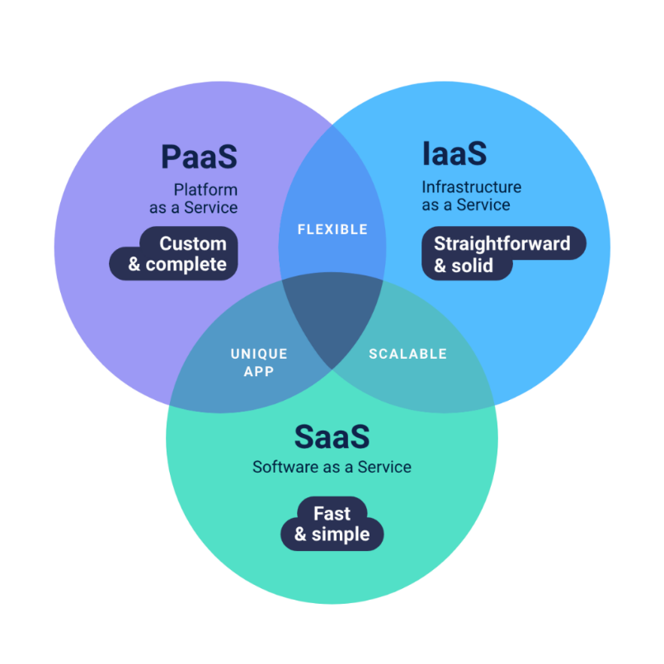Cloud Computing can further be classified using different service models as below:

Figure : Different Cloud Service Models (Elbe, 2021)

### Software as a service (SaaS)

As the name itself suggests, the SaaS vendors host the applications ensuring its availability to the users through the Internet.

### Infrastructure as a Service (IaaS)

The companies that don’t want to operate data centers in their own area or premises use this service as IaaS gives them access to virtual computing resources through the medium of internet.

### Platform as a Service (PaaS)

PaaS offers developers with an access to a platform to deploy their developed applications over the internet (Rosencrance, 2021).

## Virtualization

Virtualization technology is the technology on which cloud computing is based on. Cloud provides build and maintain their setup in their own data centers and the resources are accessed by creating different virtual environments. Virtualization allows cloud providers to create several virtual instances or computers capable of running on a single service and enables resource minimization. This simulated multiplication of resource utilization through multiple virtually simulated instances increases the efficacy and productivity if professional requirement. Virtualization in a foundational element for cloud computing as cloud computing is an essentially virtualization on a vast epic scale that enables multiple users to access the resource through single shared physical instance (Menon, 2023).

Diving deep into the topic of virtualization, there are numerous types of virtualizations which are listed below:

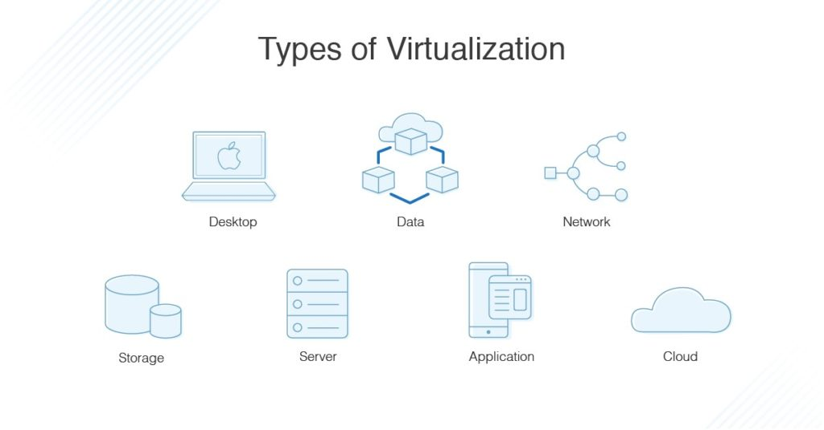

Figure : Types of Virtualizations (Kramer, 2019)

* Desktop virtualization
* Network Virtualization
* Storage Virtualization
* Application Virtualization
* GPU virtualization
* Cloud Virtualization

## Amazon Web Service

AWS, short for Amazon Web Services, is a cloud computing platform and storage service that provides organizations with a medium to securely store their important data and access different kinds of services through APIs. Amazon, the parent company of AWS, maintains a global chain network of data centers, making it a preferred choice for most organizations around the world. In fact, according to different reports, Amazon commands nearly 50% of the $32 billion public cloud infrastructure market. AWS extends its services to thousands of customers across more than 190 countries (Arora, 2023).

### Global Infrastructures

At the core of AWS’s infrastructure lies the AWS Region and Availability Zones. An AWS Region represents a distinct geographic area where multiple Availability zones are situated. Each zone comprises separate and differential data centers. These Availability Zones offer a unique advantage by allowing different organizations to run their critical databases and applications with enhanced fault tolerance, availability, scalability, and security (Bandaru, 2020).

### AWS’s Overview

#### Storage Service:

AWS provides an indigenous way with rich array of storage solutions for data storage, encompassing Amazon S3 (Simple Storage Service), Amazon EBS (Elastic Block Store), and Amazon Glacier for long term data archiving, among others.

#### Compute Services:

AWS also offers a comprehensive suite of computing resources, including Amazon EC2 (elastic Compute Cloud) for flexible server provisioning. AWS Lambda for serverless computing and so on.

#### Networking Services:

Aws expands networking capabilities with services like Amazon VPC (Virtual Private Cloud), which creates isolated network environments, and Amazon Route 53, which manages DNS (Domain Name System)

#### Identity and Security

Identity management, encryption, and security monitoring are all important parts of security and identity management. Aws provides solutions for these issues through services like Aws identity and Access Management (IAM) and AWS Security Hub.

#### Serverless computing:

AWS Lambda gives programmers the ability to run code without worrying about server administration, making it the ideal solution for scalable, event-drier applications.

#### Edge Computing:

AWS offers services like AWS Outposts and AWS Wavelength to bring cloud services loser to the network’s edge decreasing latency for crucial applications.

# Proposed Solution Architecture

## Sample Architecture Diagram for AWS

Figure 3: Architecture Structure Diagram for AWS

In the above architecture, it is basically divided into two Availability Zones (AZs), isolated from each other to improve toleration of faults and errors. In each Availability Zone, there are different public and private subnets. In the public subnet, the Application Load Balancer (ALB) and other resources that requires access via the internet are housed and resources like Amazon EC2 instances and Amazon Relational Database Service (RDS) instances which must be reachable from within the VPC but not internet are included in private subnets. The Bastion Host, a dedicated EC2 install is utilized in order to safely access the private subnet from the internet. The private subnet’s EC2 instances can access the internet thanks to the NAT Gateway without needing directly exposed to the public internet. By automatically starting and stopping EC2 instances according to the demand, the application’s availability is made sure by Auto scaling group.

# Services Used

## Amazon EC2

Amazon EC2 generally referred to as Amazon Elastic Compute Cloud is a online service that offers safe, scalable computer capability in the cloud. For developers, it is intended to make web-scale cloud computing simpler. This is a straightforward service interface which makes it easy for organizations to get and set up capacity where they will be able to have control over their computing resource and can test computing environments. With the help of Amazon EC2, organizations can swiftly grow the capacity as the computing needs vary by reducing the time needed to purchase and boot additional server instances to minutes. Amazon EC2 transforms this computing economics as it allows organization to only pay for the capacity that is really required by them (Misk, 2013).

## Amazon RDS

Amazon RDS, generally referred to Amazon Relational Database Service is a web service that enables simpler set up and allows to run and scale a relational database more easily. This service in Amazon cloud performs typical database administration activities and offers affordable, resizable capacity for an industry-standard relational database as Amazon RDS is a managed database service. This makes the set up and process easier by eliminating tedious manual tasks and frees organization to focus on application more (G., 2018).

## Amazon Elastic Load Balancer

Elastic Load Balancer (ELB) is a service that AWS offers which splits the incoming application traffic automatically among numerous targets and virtual appliances in multiple Availability Zones (AZs). The incoming loads are split among numerous targets, including EC2 instances, containers and IP addresses among different Availability Zones. Elastic Load Balancer also helps to keep track of the well-being of registered targets as it analyzes and sends the traffic to those that are in good shape. Elastic Load Balancing automatically adjusts the capacity of load balancer by analyzing the incoming traffic (Mangayarkarasi).

## AWS System Manager

A service that offers a browser-based interactive shell, CLI and browser-based remote desktop access for management of instances in cloud, premises, and edge devices without the need to open inbound ports, manage Secure Shell (SSH) keys, or employ bastion hosts. AWS System Manager is also known as SSM where users can execute remote commands without managing SSH and automate operations across the AWS resources. AWS System Manager aids in maintain the security and compliance by scanning the managed nodes (Gaur, 2023).

## Auto Scaling

Auto Scaling is an Amazon service that helps organizations to maximize their utilization and cost efficiency to manage payment as per organization’s utilization of resources that they actually need. AWS Auto Scaling will automatically eradicate any extra resource capacity when demand declines which saves a certain amount for organization. It is a cost-free service that enables organization to reduce their expense associated with their AWS setup (SentinelOne, 2021).

## Virtual Private Cloud (VPC)

Amazon Web Service provides a great service with the use of which organizations are allowed to start up AWS resources in a private predefined virtual network logically separated with Amazon Virtual Private Cloud (Amazon VPC). There is a significant advantage of using Amazon VPC as it allows use of the scalable infrastructure of AWS while closely resembling a network that is conventional where organization can operate their own data center. The utilization of Amazon VPC means logically isolating from other networks where subnets, gateways and security groups can be configured as well as selecting an IP address range for the VPC (Vacca, 2017).

# Possible Solutions

## Availability

Several solutions have been explored and developed to address the issues that were previously stated by Shirley of her website to ensure the dependability, responsiveness, and resilience of the website while utilizing AWS service.

### Amazon ELB (Elastic Load Balancer)

Distributing traffic among numerous EC2 instances in various Availability Zones adds a layer of availability and fault tolerance. The website is still available to browse even if there exist problems in particular Availability Zones.

### Disaster Recovery Plans:

To build reliable disaster recovery plans, AWS Backup and AWS VPN are combined. Even in the face of foreseen circumstances, this tactical combination makes sure that data recovery and availability are given priority.

### Amazon EC2 Scalability

By using automatic resource scaling and various Availability Zone deployments, EC2 instances can withstand traffic spiked without going offline, providing customers with high availability.

Multi-Availability Zone Replication:

The database is replicated across various Availability Zones when Amazon RDS Multi AZ is used. This redundancy ensures that even if one Availability goes down, the database will still be accessible.

### Virtual Private Cloud (VPC)

Resources can be launched through virtual networks from a logically isolated area of the AWS cloud called a VPC. By enabling organizations to create their own network topology, set up routing, and manage traffic flow. It offers network level security to make the resource secure as organizations will be able to configure VPC subnets, security groups, and Network Access Control Lists (NACLs).

## Scalability

### Amazon EC2 Auto Scaling:

Utilizing Amazon EC2 Auto Scaling enables instances to be automatically adjusted based on changes in traffic, improving both performance and cost-effectiveness in accordance with AWS-recommended standards.

### Amazon RDS Database Replicas:

It is advised to use Amazon RDS to create database replicas to accommodate increased read loads to improve scalability while maintaining effective database operations. This replica of database will help in smooth scalability of database operations with certain improvisations.

### Auto Scaling:

Using Auto Scaling to flexibly change the number of EC2 instances in response to traffic demands is in line with AWS best practices for scaling.

### Serverless Option:

AWS Lambda: When employing serverless computing. Considering the use of AWS Lambda will automatically scale the handling process of the workload, to offloading of specific tasks or operations from organization’s PHP application. This lessens the requirement for traditional servers to be managed.

## Security

### Secure Configuration of Amazon EC2 instances

A core AWS best practice for preventing security threats and data breachers is to guarantee the secure configurations and ongoing administration of Amazon EC2 instances.

### Amazon RDS Security Features:

Utilizing the security features of Amazon RDS, such as encryption, database authentication and access controls, strengthens the security of database and its contents while adhering to the security procedures advised by AWS.

### Security Management and Automation

AWS System’s Manager’s role in automating and managing security tasks efficiently aligns with AWS. practices for enhancing overall security. Automation of security operations including patch management, compliance monitoring, and system setup is possible with AWS system manager. Utilizing these automation technologies can improve overall security posture and expedite security management.

### Encryption:

For data encryption in Shirley’s database, utilization of the AWS Key Management Service (KMS) would be perfect. Additionally, enforcement of SSK/TLS encryption for information travelling between the database and query page or PHP application can be implemented.

### Access Control:

IAM Roles: Utilization of the least privileged concept to define IAM roles. For instance, only grant EC2 instances the access rights necessary to the AWS Systems Manager Parameter Store.

### Web Application Firewall

WAF Rules: To filter and block harmful traffic, set up AWS Web Application Firewall (WAF) rules. Design the WAF rules in such a way to stop SQL injection or cross site scripting (XSS) attacks and other harmful attacks.

# Data Migration

## AWS Database Migration Service

When it comes to Data Migration, one of the services provided by AWS, that is AWS Database Migration Service can be implemented. AWS Database Migration Service is a cloud service that allows to move or migrate various relational databases, data warehouses, NoSQL databases, and other kinds of data storage. AWS DMS allows to move data into AWS cloud to between hybrid cloud and on-premises configures. Using AWS Database Migration Service can be very beneficial as it is a robust and reliable tool capable of streamlining the process of database migration to AWS Cloud smoothly (AWS, 2021).

In the context of Example Social Research Organization, transition of their MySQL database to Amazon RDS can be made smooth with AWS DMS. With the help of AWS Database Migration Service, the source MySQL database can be connected to Amazon RDS instance. This will allow our team to configure the replication endpoints, where the target Amazon RDS instance and the information regarding the source MySQL database are both provided. Processes like data extraction, transformation, and loading (ETL) from the source to the target will be performed by DMS after it is configured. AWS Database Migration Service can carry both full load and ongoing replication in order to make sure that the data is constantly synchronized between the source and Amazon RDS.

## Amazon RDS (Relational Database Service)

As previously mentioned, Amazon RDS refers to a web service that makes it easier to set up, run, and scale a relational database. As Amazon RDS is a managed database service, it is capable of handling the common database management process and services affordable and scalable capacity for a relational database that is of industrial standard. This is beneficial to organizations as it eradicates tiresome manual processes and allows organizations to concentrate more on the application.

In the context of Example Social Research Organization, the Amazon RDS compliments the migration process of MySQL database of organization as it offers a fully managed environment that is dependable, scalable, and high performance for database operations. For Example, Social Research Organization, RDS will provide a MySQL database engine that has been tuned for hosting research statics data. After the creation of RDS instance, the company can customize it by configuring and changing the instance type, storage options and security settings that suit the unique requirements of the Example Social Research Organization’s website. Utilization of Amazon RDS will relieve the organization of the operational strain by handling the database administration duties which contains backups, patching and maintenance. To control the flow of website’s traffic, it can simply be scaled up and down in order to interface other AWS services easily. Amazon RDS ensures data integrity and availability as it provides encryption options and strong security controls in order to protect the sensitive research data, Switching to Amazon RDS will allow firm to gain more responsive and secure database which eventually improves the functionality of their websites and offers an effective platform for retrieving statistical data.

### Migration of MySQL database to Amazon RDS steps

# Conclusion

Our team has successfully created and transferred the Example Social Research Organization’s website to AWS cloud with a more detailed plan and architecture. The plan and architecture were created by keeping our aim and objectives in mind to meet all requirements of the project which was to ensure the availability, security and scalability of the organization’s website and data. In this architecture, various Amazon Web Services have been utilized such as Amazon RDS, Amazon DMS, VPC, Amazon WAF, Amazon EC2, Amazon ELB and many others. These various services were planned and designed to ensure the migration of the PHP based website and MySQL database to Amazon cloud was smooth. These services will ensure the security and scalability of the website as they enforce more robust, reliable and a secure platform for the organization’s website to operate.

# References

Arora, S. (2023, February 13). IT Service and Architecture. *Introduction to Amazon Web Services (AWS)*. Retrieved October 3, 2023, from https://www.simplilearn.com/introduction-to-amazon-web-services-aws-article

AWS. (2021, March 8). *Modernizing the Amazon*. Retrieved October 2, 2023, from AWS: https://d1.awsstatic.com/whitepapers/modernizing-amazon-database-infrastructure.pdf

Bandaru, A. (2020). AMAZON WEB SERVICES. *Analyzing the Network for AWS Distributed Cloud Computing*. Retrieved October 3, 2023, from https://www.researchgate.net/publication/347442916_AMAZON_WEB_SERVICES

Elbe, D. (2021, July). *PaaS vs IaaS vs SaaS — differences, pros, and cons.* Retrieved October 3, 2023, from Artifakt: https://www.artifakt.com/blog/paas/paas-vs-iaas-vs-saas-differences-pros-and-cons/

G., L. N. (2018, April). Database Migration on Premises to AWS RDS. *Endorsed Transactions on Cloud Systems*. doi:http://dx.doi.org/10.4108/eai.11-4-2018.154463

Gaur, B. (2023, May 30). AWS System Manager. *AWS SSM: Everything you need to know*. Retrieved October 2, 2023, from https://k21academy.com/amazon-web-services/aws-systems-manager/

Kramer. (2019, December 10). *Virtualization Technology vs. Cloud Virtualization*. Retrieved October 3, 2023, from dnsstuff: https://www.dnsstuff.com/virtualization-technology-cloud-computing-types

Mangayarkarasi. (n.d.). IOP Conference Series: Materials Science and Engineering. doi:10.1088/1757-899X/1055/1/012113

Menon, K. (2023, September 1). Virtualization in cloud computing. *Virtualization in cloud computing - The Complete Guide*. Retrieved October 1, 2023, from https://www.simplilearn.com/virtualization-in-cloud-computing-article

Misk, N. (2013, September). International Journal of Computer Networks and Communications. *Cloud Computing Challenges with Emphasis on Amazon EC2 and Windows Azur*, 35-44. doi:http://dx.doi.org/10.5121/ijcnc.2013.5503

Ranger, S. (2022, February 25). Cloud. *What is cloud computing? Everything you need to know about the cloud explained*. Retrieved October 1, 2023, from https://www.zdnet.com/article/what-is-cloud-computing-everything-you-need-to-know-about-the-cloud/

Rosencrance, L. (2021, December 20). *SaaS vs. IaaS vs. PaaS*. Retrieved October 1, 2023, from techtarget: https://www.techtarget.com/whatis/SaaS-IaaS-PaaS-Comparing-Cloud-Service-Models#:~:text=There%20are%20three%20major%20cloud,use%20and%20subscription%20pricing%20models.

SentinelOne. (2021, July 10). *AWS Auto Scaling: Intro, Strategies & Tips to.* Retrieved October 2, 2023, from SentinelOne: https://www.sentinelone.com/wp-content/uploads/pdf-gen/1666871502/aws-auto-scaling-intro-strategies-tips-to-keep-in-mind.pdf

Vacca, J. R. (2017). *Computer and Information Security Handbook.* Morgan Kaufmann.